**DAILY ONLINE ACTIVITIES SUMMARY**

|  |  |  |  |  |  |  |  |  |
| --- | --- | --- | --- | --- | --- | --- | --- | --- |
| **Date:** | **05-7-2020** | | | | | **Name:** | **poojashree** | |
| **Sem & Sec** | **8th sem A sec** | | | | | **USN:** | **4al16cs065** | |
| **Online Test Summary** | | | | | | | | |
| **Subject** | | **sms** | | | | | | |
| **Max. Marks** | |  | | **Score** | | |  | |
| **Certification Course Summary** | | | | | | | | |
| **Course** | **Introduction to cyber security** | | | | | | | |
| **Certificate Provider** | | | **Great learning academy** | | **Duration** | | | **5.5hr** |
| **Coding Challenges** | | | | | | | | |
| **Problem Statement:**  **1. print the c program to find nonrepeating element in array** | | | | | | | | |
| **Status:completed** | | | | | | | | |
| **Uploaded the report in Github** | | | | | **yes** | | | |
| **If yes Repository name** | | | | | **Poojashree** | | | |
| **Uploaded the report in slack** | | | | | **yes** | | | |

**Online test**

**----------no marks -----------**

**Certification course**

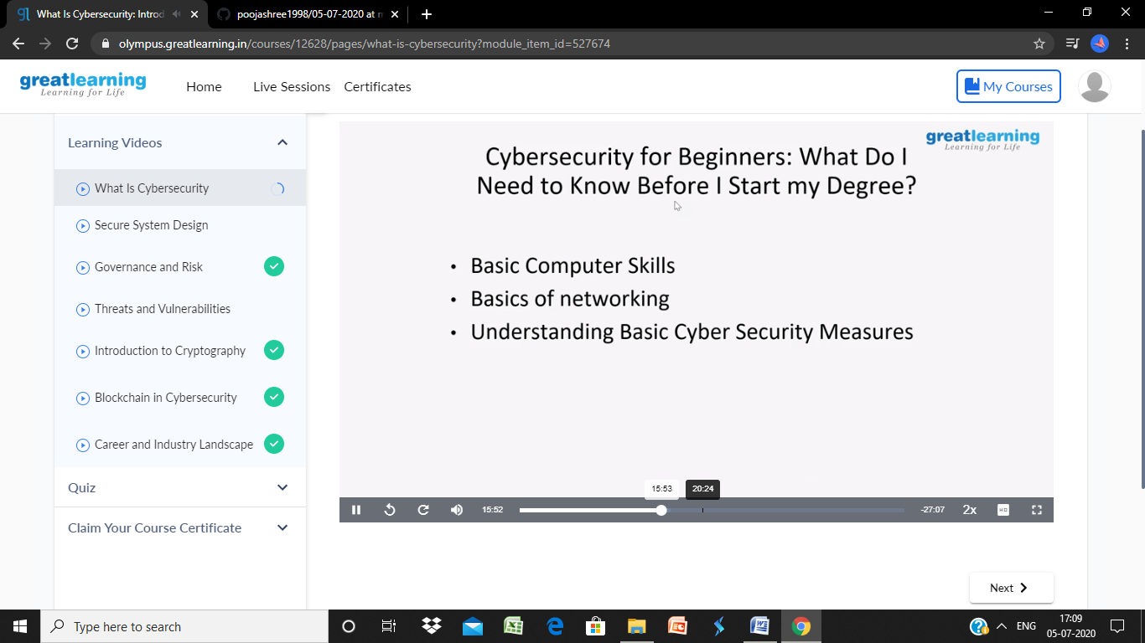

**Coding**

**Program 1**

**#include <stdio.h>**

**#include <stdlib.h>**

**int non_repeating_elements(int arr[], int n)**

**{**

**int i,j;**

**int count = 1;**

**for(i = 0; i < n; i++)**

**{**

**for(j = 0; j < n; j++)**

**{**

**if(arr[i] == arr[j] && i != j)**

**break;**

**}**

**if(j == n )**

**{**

**printf("\nNon-repeating element [%d] : %d \n",count,arr[i]);**

**++count;**

**}**

**}**

**return -1;**

**}**

**int main()**

**{**

**int n,i;**

**printf("\nEnter the number of elements : ");**

**scanf("%d",&n);**

**int arr[n];**

**printf("\nInput the array elements : ");**

**for(i = 0; i < n; i++)**

**{**

**scanf("%d",&arr[i]);**

**}**

**non_repeating_elements(arr, n);**

**return 0;**

**}**